- Template for Student Profile Form
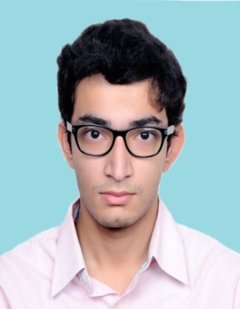
Name: RAMESH KUMAR
Date of Birth: 01-01-1998
Permanent Address: Plot number-45, Hari Nagar, New Delhi-110065
Current Address: same as permanent address
Contact No.: +91XXXXXXX
Email: xyz@gmail.com
Academic Qualification:
Class | University/ Board | Institution | Percentage/ CGPA | Year of Passing | Remark
B.Tech/ B.Sc |  |  | 1st Year:
B.Tech/ B.Sc |  |  | 2nd Year:
B.Tech/ B.Sc |  |  | 3rd Year:
12th
10th

Workshop/Training:
- 2 months training on “Topic” from 15th May to 15th July, 2015 at TCS Bangalore
- 2 days workshop on “DNA Fingerprinting” organized by “Organising Institute / Organiser” at venue Details
Curricular/Extra-Curricular Activity:
- Participated in ______________

Department of _______________
STUDENTS’ PROFILE

Font: Times New Roman
Font size 12
(see the example attached below)
- Attach a copy of supporting documents for Academic Qualification,
Workshop/Training and Curricular/Extra-Curricular Activity
Recent Passport Sized Coloured Photograpgh
35 mm X 45 mm
(blue background and in formal wear)
- Note: Students must restrict to this format only

Name:
Date of Birth: DD-MM-YYYY
Permanent Address:
Current Address: (if different from Permanent Address)
Contact No.:
Email:
Academic Qualification:
Class | University/ Board | Institution | Percentage/ CGPA | Year of Passing | Remark
B.Tech/ B.Sc |  |  | 1st Year:
B.Tech/ B.Sc |  |  | 2nd Year:
B.Tech/ B.Sc |  |  | 3rd Year:
12th
10th

Workshop/Training:

Curricular/Extra-Curricular Activity:

